**Cloud Watch (9/09/2024)**

**Problem Statement**- Monitor the CPU utilization and set threshold of utilization greater than 80% and send a alert via SNS.

1. Create instance –

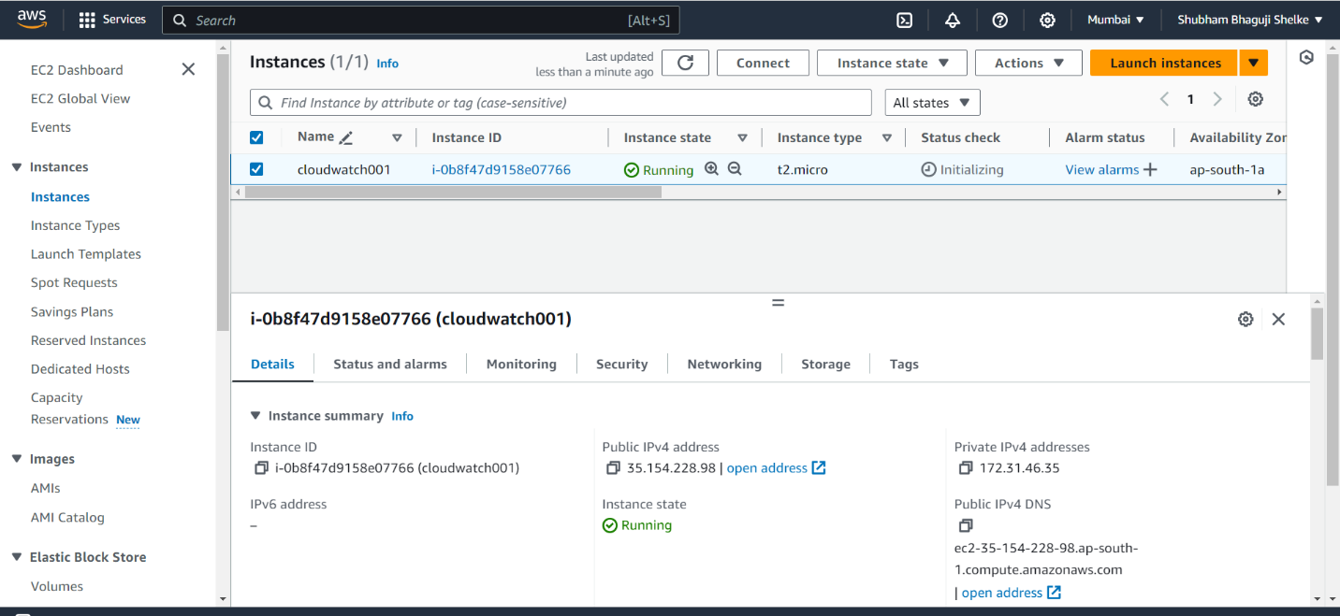

2. Go to SNS service and create standard topic

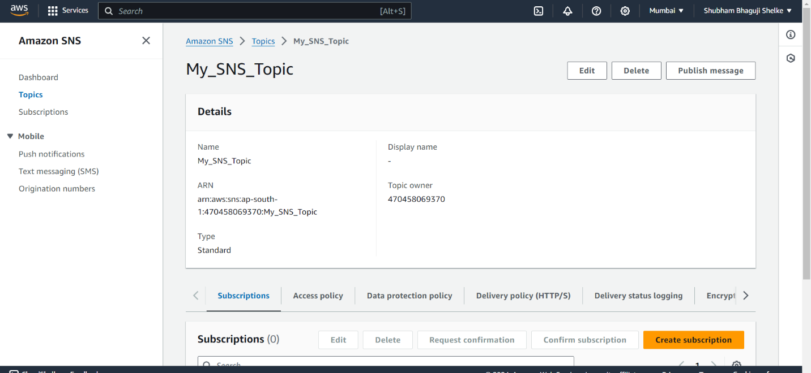

3. Create subscription in newly created SNS topic (My SNS Topic) and add Email id.

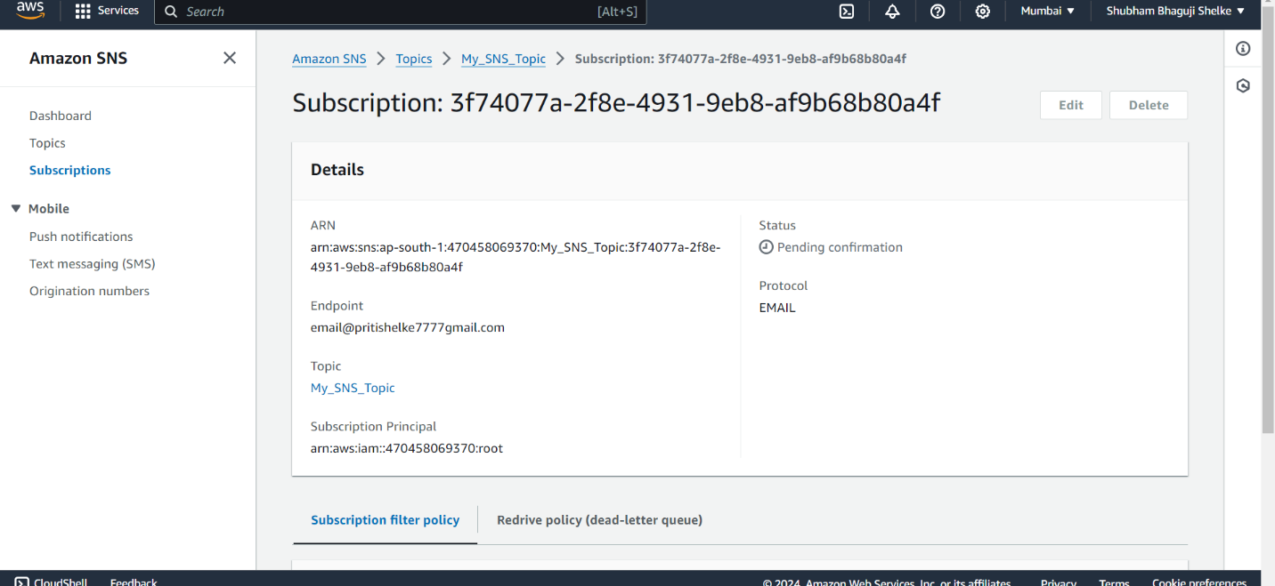

4. After conformation, status changes to “confirmed”

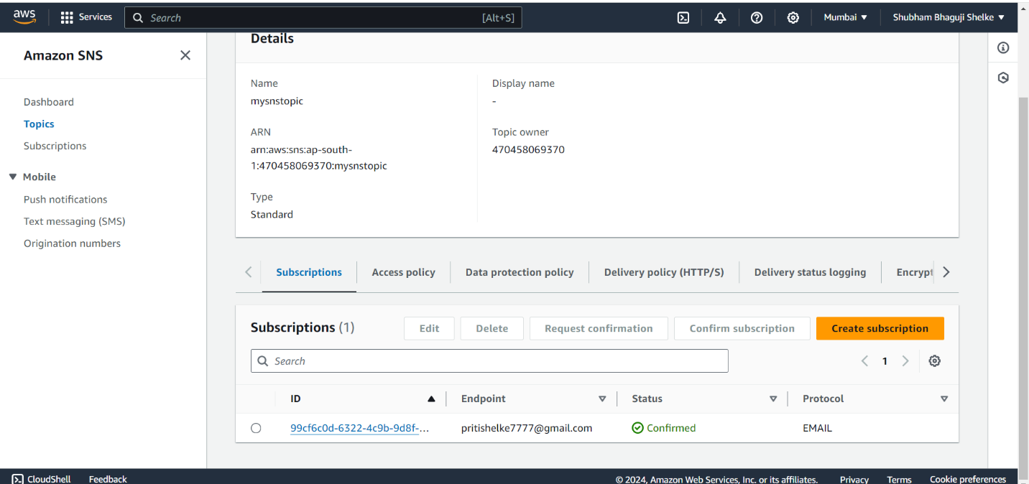

5. GO to “CloudWatch” service and create alarm

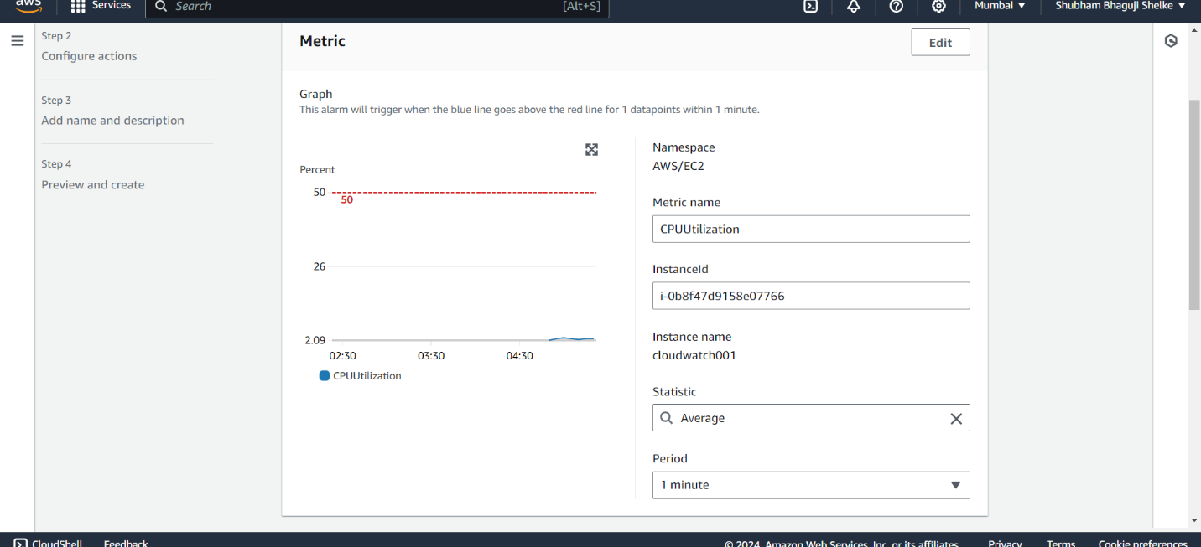

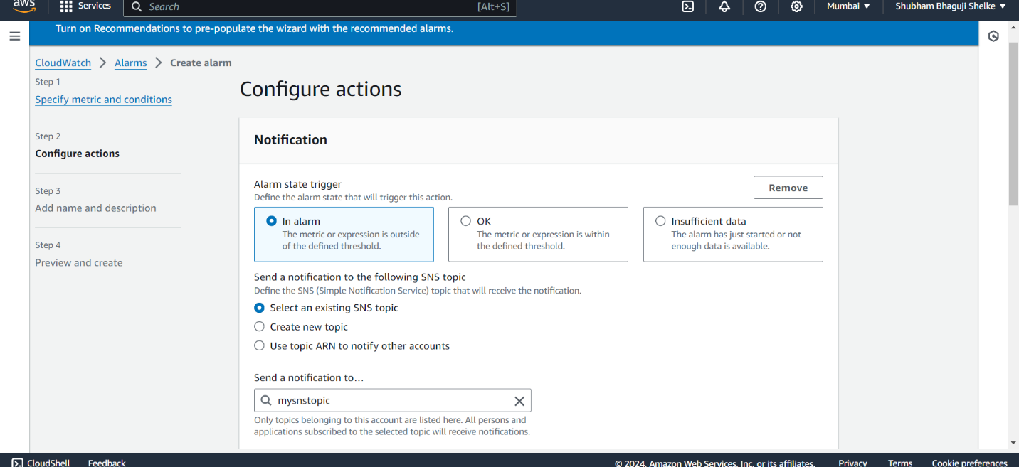

6. Alarm successfully created

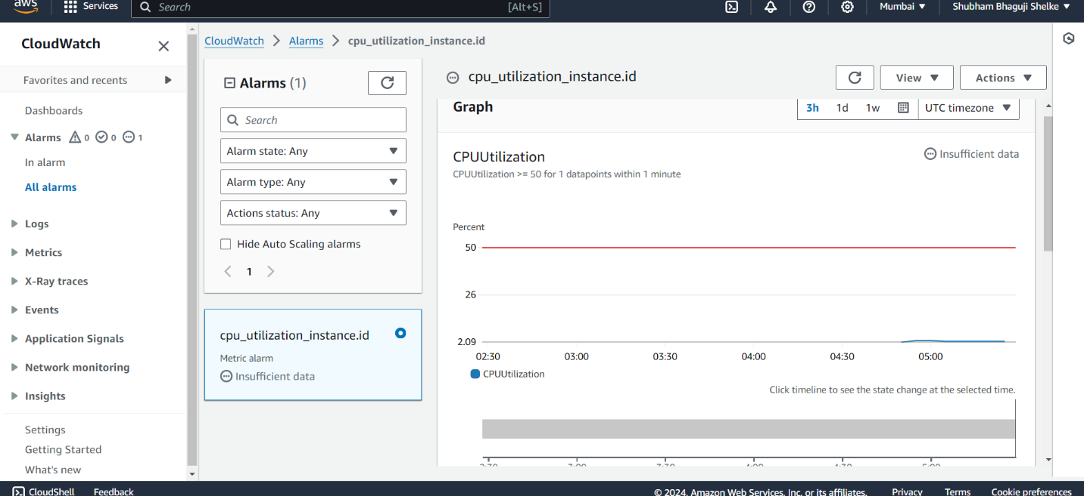

7. Goto instance and manually increase CPU utilization (sudo su, top)

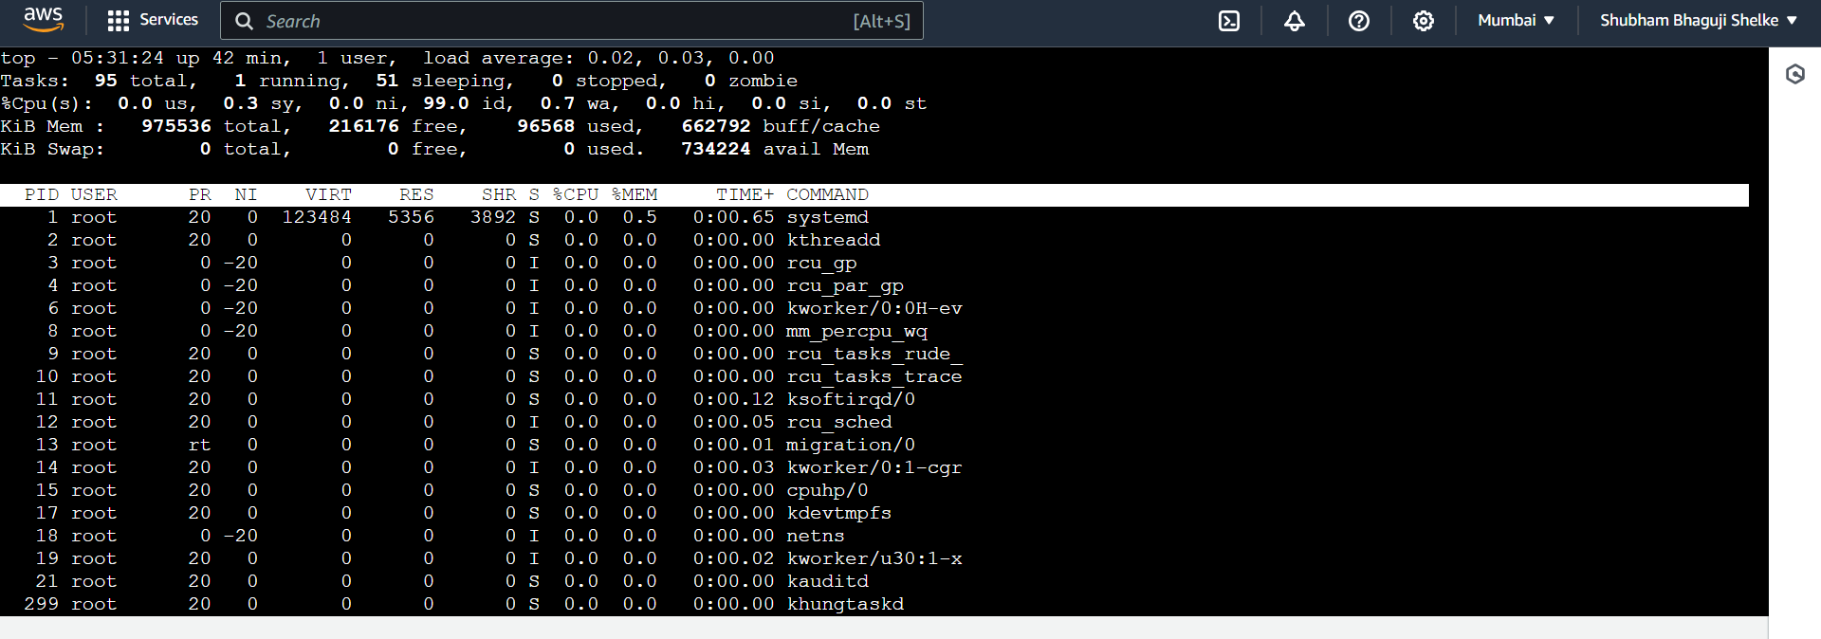

8. Install stress package in Linux (yum install -y)

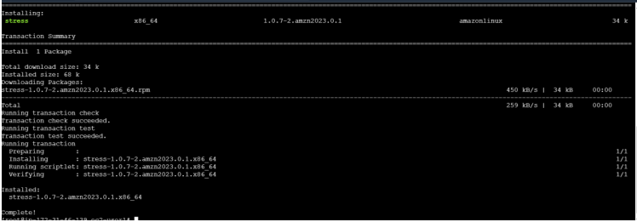

9. Check CPU utilization in CloudWatch alarm which we created.

